Currently, Numpy recommend a command line method to run test case as demonstrated in [Testing Guidelines](https://numpy.org/devdocs/reference/testing.html#testing-guidelines) ,Which is heavy and inconvenient, It's also a little painful if test cases can not debug in a visualize way, I happened to find an easier way to running and debugging numpy test case as below:

**1.Download VS Code**[**here**](https://code.visualstudio.com/Download)**.**

**2.Open numpy source folder. File -> Open Folder.**

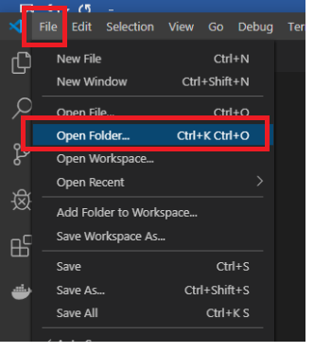

**3.Install the Python extension from your extensions:**

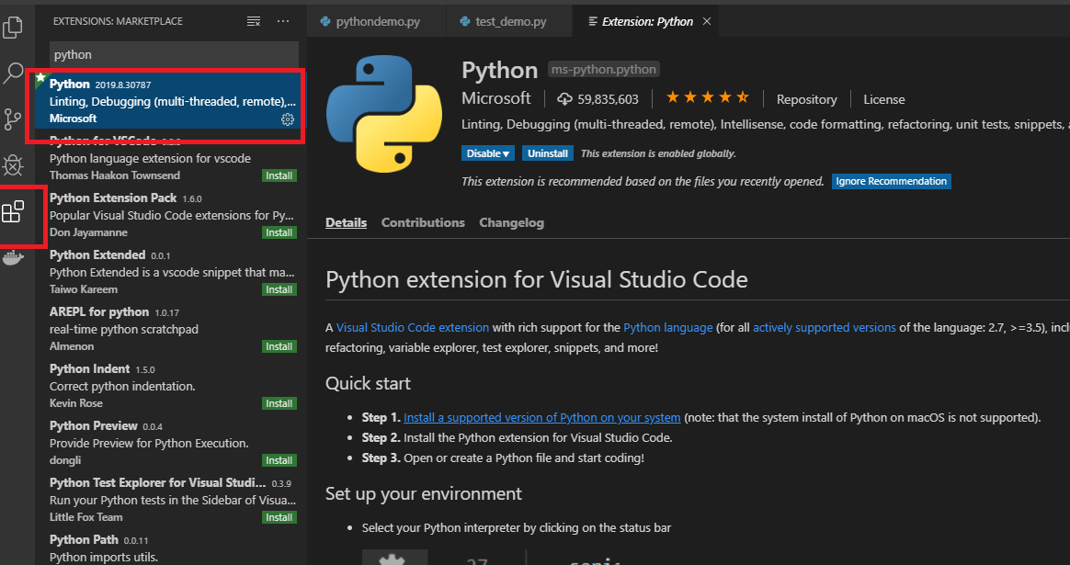

**4.Configuring Tests: Pytest**

The VS Code Python extension supports unit tests as well as **pytest**. Here's how to enable the framework:

Open **Command Palette (**ctrl +shift +P) and start typing ‘python: configure tests.’ It will display a list of available python linters. You can add any of the settings to your user settings.json file (opened with the **File** > **Preferences** > **Settings)**

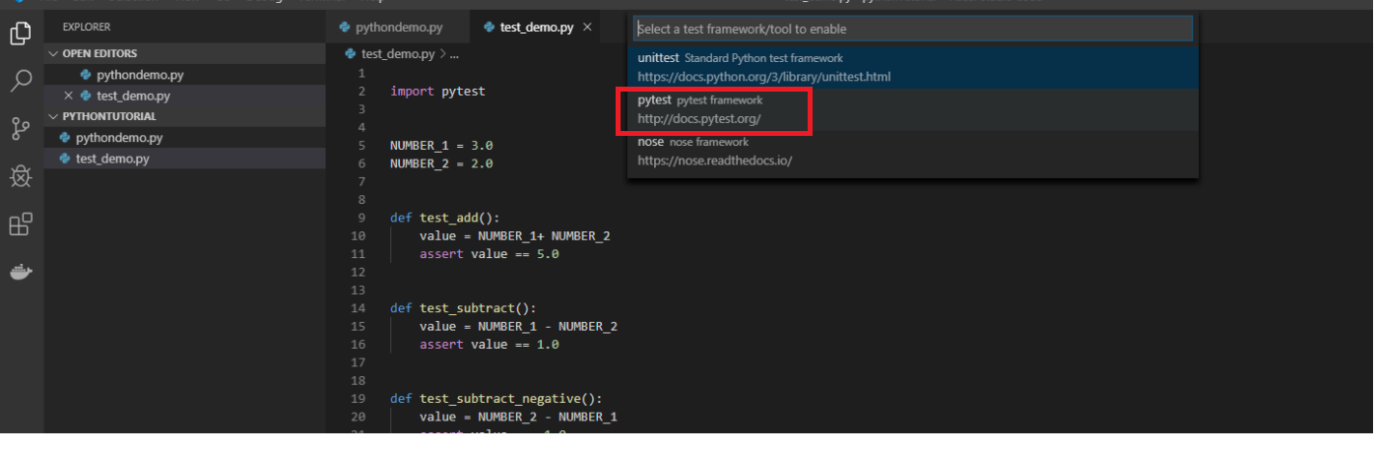

Edit the settings.json file like this:

{

    "python.pythonPath": "C:\\Python36\\python.exe",

    "python.linting.pylintEnabled": true,

    "python.linting.enabled": true,

    "python.testing.unittestEnabled": false,

    "python.testing.nosetestsEnabled": false,

    "python.testing.pytestEnabled": true,

    "python.testing.pytestArgs": [

        "./numpy/tests/",

        "./numpy/core/tests/"

    ]

}

Click "Discover Tests"

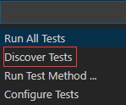

Then you can running and debugging any test case that you want.

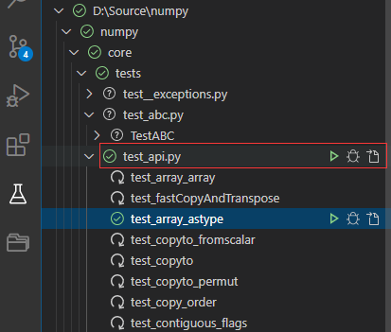

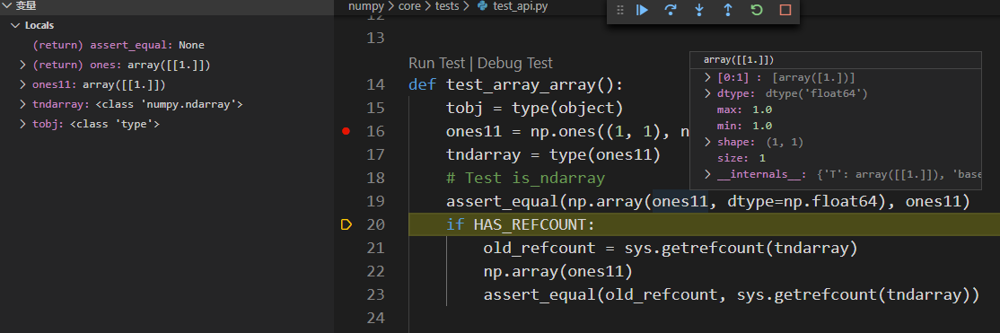

The fallback of this method is that you have to rebuild numpy before execute testcase if you changed numpy's source code.